## notes

|  |  |  |
| --- | --- | --- |
| Gray matter |  |  |
| Strict | /strɪkt/ |  |
| Rejuvenated  Regenerative  Updated, re-novated | /rɪˈdʒuːvəneɪtɪd/ | 使年轻 |

|  |  |  |
| --- | --- | --- |
| Daily grind | /ˈdeɪli ɡraɪnd/ | A tiresome, difficult, or monotonous daily work routine  [day to day work](javascript:;); [routine work](javascript:;) |
| Burned out | /bɜːnd/ | So exhausted from working too hard that you can’t perform well or no longer care about the job or your performance  焦头烂额 |
| overworked | /ˌəʊvəˈwɜːkt/ | Having worked too hard or for too long  Overworked adult |
| Refreshed | /rɪˈfreʃt/ | Feeling rested and renewed  recreative |
| To unwind | /ˌʌnˈwaɪnd/ | To become relaxed |
| arrange | /əˈreɪndʒ/ |  |

## lessons

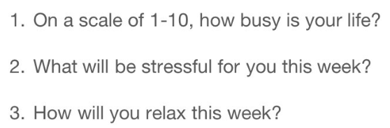

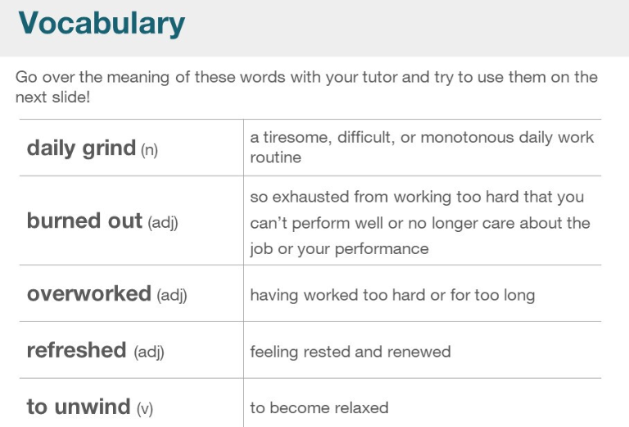

|  |  |  |
| --- | --- | --- |
| Daily grind | /ˈdeɪli ɡraɪnd/ | A tiresome, difficult, or monotonous daily work routine  [day to day work](javascript:;); [routine work](javascript:;) |
| Burned out | /bɜːnd/ | So exhausted from working too hard that you can’t perform well or no longer care about the job or your performance  焦头烂额 |
| overworked | /ˌəʊvəˈwɜːkt/ | Having worked too hard or for too long  Overworked adult |
| Refreshed | /rɪˈfreʃt/ | Feeling rested and renewed  recreative |
| To unwind | /ˌʌnˈwaɪnd/ | To become relaxed |

